# Assignment -3

Python Programming

|  |  |
| --- | --- |
| Assignment Date | 07 November 2022 |
| Team ID | PNT2022TMID44153 |
| Student Name | MOHAMMED MUSTHAKEEM A |
| Student Roll Number | 724019104012 |
| Maximum Marks | 2 Marks |

# Question:

Write python code for blinking LED and Traffic lights for Raspberry pi. Only python code is enough, no need to execute in raspberry pi.

# Solution: Program

import turtle import time

wn= turtle.getscreen() wn.title("Stoplight By AjmeerKaja") wn.bgcolor("black")

pen= turtle.Turtle() pen.color("Yellow") pen.width(4) pen.hideturtle() pen.penup() pen.goto(-30, 60) pen.pendown() pen.fd(60) pen.rt(90) pen.fd(120) pen.rt(90) pen.fd(60) pen.rt(90) pen.fd(120)

#red light

red_light =turtle.Turtle() red_light.shape("circle") red_light.color("grey") red_light.penup() red_light.goto(0, 40) #Yellow light

yellow_light =turtle.Turtle() yellow_light.shape("circle") yellow_light.color("grey") yellow_light.penup() yellow_light.goto(0, 0) #Green light

green_light =turtle.Turtle() green_light.shape("circle") green_light.color("grey") green_light.penup() green_light.goto(0, -40) while True:

yellow_light.color("grey") red_light.color("red")

print("Red light Blinked - Now vehicle Stop behind zebra cross..") print("Blink!!")

time.sleep(2) print("Blink!!") red_light.color("grey") green_light.color("green")

print("Green light on- Now vehicle can go..") print("Blink!!")

time.sleep(3) print("Blink!!") green_light.color("grey")

yellow_light.color("yellow")

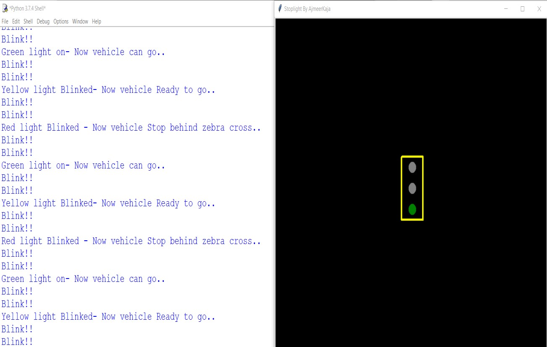

print("Yellow light Blinked- Now vehicle Ready to go..") print("Blink!!")

time.sleep(1) print("Blink!!")

wn.mainloop()

# Output: